

***OCEAN GATE***

**E-Project Documentation**

**Teacher Name: Sir Shadab**

**APTECH COMPUTER EDUCATION**

**HYDERABAD-1 PAKISTAN**

**Issue Date: 04-May-2025**

TABLE OF CONTENT

|  |  |  |
| --- | --- | --- |
| **S No** | **Contents** | **Page No** |
| 01 | Certificate | 3 |
| 02 | Acknowledgement | 4 |
| 03 | Project Report | 5 |
| 04 | Problem Definition | 6 |
| 05 | Customer Requirements Specification  (CRS) | 7 |
| 06 | Architecture Design of the Project | 9 |
| 07 | System Requirement | 10 |
| 08 | Task Sheet | 11 |
| 09 | Project Plan | 13 |
| 10 | Checklist of work Progress | 14 |
|  |  |  |
| 11 | Screen Shots | 15 |
| 12 | Source Code | 19 |

CERTIFICATE

This is to certify that

**SYED ANAS ALI, SABOOR SAMOO, HYDER MEMON, MURTAZA ALI AND SYED BILAL**

Has successfully designed

**OCEAN GATE**

Submitted by:

**SYED ANAS ALI, SABOOR SAMOO,HYDER MEMON, MURTAZA ALI AND SYED BILAL**

Date of Issue: 04-May-2025

**Authorized Signature:** Shadab

ACKNOWLEDGEMENT

First and foremost, we would like to express our deep gratitude and most heartfelt thanks to almighty ALLAH for his blessings, for lightening up our heart with the torch of knowledge and for giving us the ability to complete this project.

We would like to thanks Aptech Worldwide and the team of E-Project for their generous support and clarifying the doubts regarding e-project. We would like to acknowledge the way of explanation which the team of e-project gave in e-project to make website and we are equally grateful to our teacher (Sir Shadab) for giving us a moral support and guiding us different matters regarding project in all the time about the research and writing of this project.

We are greatly indebted to Aptech Worldwide, Sir Shadab, Faculty Members and ACE Hyderabad, Pakistan for encouragement and incessant help.

PROJECT REPORT

**Project Title: OCEAN GATE**

**Members Name: SYED ANAS ALI, SABOOR SAMOO, HYDER MEMON, MURTAZA ALI AND SYED BILAL**

**Batch Code: 2412F**

**Start Date: 04-May-2025**

**End Date: 26-May-2025**

**Course: CPISM**

**Teacher: Sir Shadab**

**Center Academic Head: Shoaib Ahmed**

**Center Name: ACE Hyderabad-1, Pakistan**

Submitted as

E Project Documentation

**PROJECT STATEMENT**

The Ocean Gate website will provide a comprehensive, interactive experience for DVD and CDS, making it the go-to resource for knowledge, community, and market insights.

System Requirement:

|  |  |  |
| --- | --- | --- |
| **SR.No** | **Items** | **Description** |
| 01 | Operating System | Window XP, Win7 or win8 |
| 02 | Main Processor | Minimum 2ghz or better |
| 03 | Ram (Memory) | Minimum 512mb or better |
| 04 | Web Browser | Google Chrome or Firefox (Latest) |
| 05 | Software | Windows OS/JAVA/Android SDK/Notepad/SQL/Dart/Flutter |

TASK SHEET

|  |  |  |  |  |  |
| --- | --- | --- | --- | --- | --- |
| **Project Ref. No:** | | **Date of Preparation of Activity Plan:** | | | |
| SR.  No | Task | Actual  Start  Date: | Actual  Day: | Team  Mates  Names: | Status: |
| 01 | Meeting | 06-May-2025 | 1 | Syed Anas Ali, Saboor Samo, Murtaza, Hyder Memon | YES |
| 02 | Data  Collection | 8-May -2025 | 2 | Syed Anas Ali, Saboor Samo | YES |
| 03 | Designing  Home  Page | 12-May-2025 | 3 | Syed Anas Ali | YES |
| 04 | Linking | 14-May-2025 | 4 | Syed Anas Ali, Saboor , Murtaza | YES |
| 05 | Check  Links | 15-May-2025 | 5 | Hyder Memon | YES |
| 06 | Finalizing | 20-May-2025 | 6 | Syed Anas Ali, Saboor Samu, Murtaza, Hyder, Bilal | YES |
| 07 | Testing | 20-May-2025 | 7 | Saboor Samoo | YES |
| 08 | Documentation | 22-May-2025 | 8 | Syed Anas Ali | YES |
| 09 | Uploading | 26-May-2025 | 9 | Syed Anas Ali | YES |

CHECK LIST OF WORK PROGRESS

|  |  |  |
| --- | --- | --- |
| **SR.No** | **Aspect Tested** | **Remarks** |
| 01 | Data Collection | **Yes** |
| 02 | Designing Home Page | **Yes** |
| 05 | Linking The Pages | **Yes** |
| 06 | Finalization | **Yes** |
| 08 | Tasting The Site | **Yes** |
| 09 | Documentation | **Yes** |

**SCREEN SHOTS**

**HomePage:**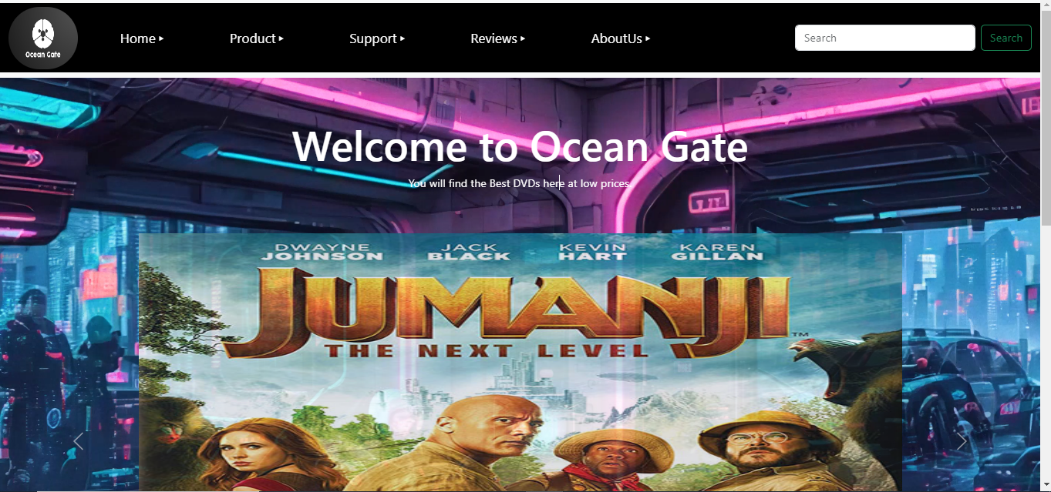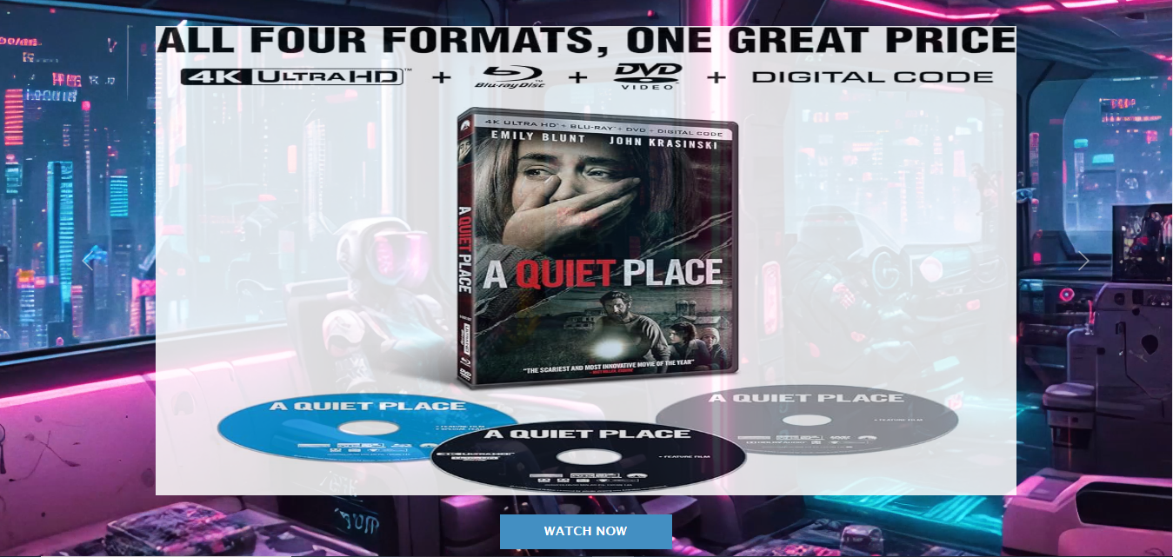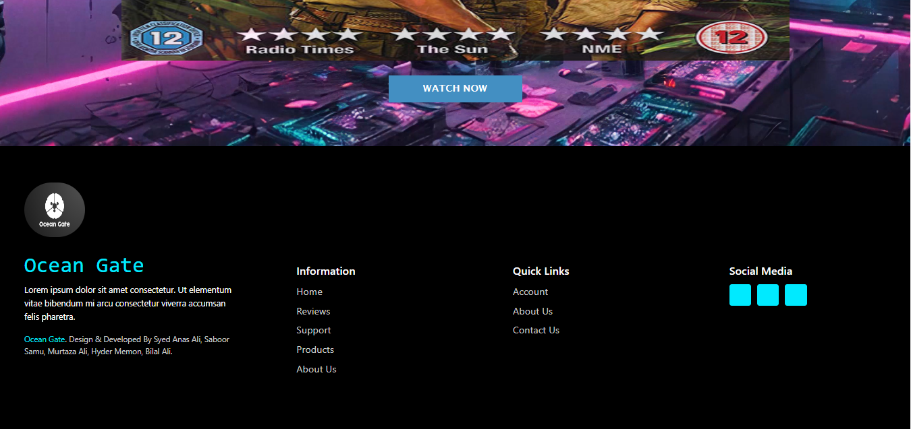

# **ProductPage**headerC:\Users\dell\Desktop\screenshots\ssproduct2.PNGssproduct2C:\Users\dell\Desktop\screenshots\ssproduct3.PNGssproduct3

# SupportPage:C:\Users\dell\Desktop\screenshots\sssupport1.PNGsssupport1C:\Users\dell\Desktop\screenshots\sssupport2.PNGsssupport2

**Reviews Page:**

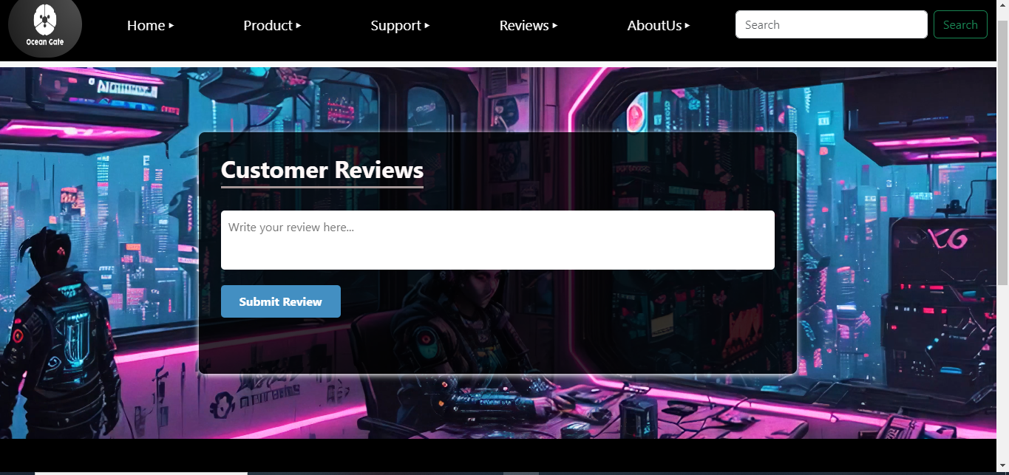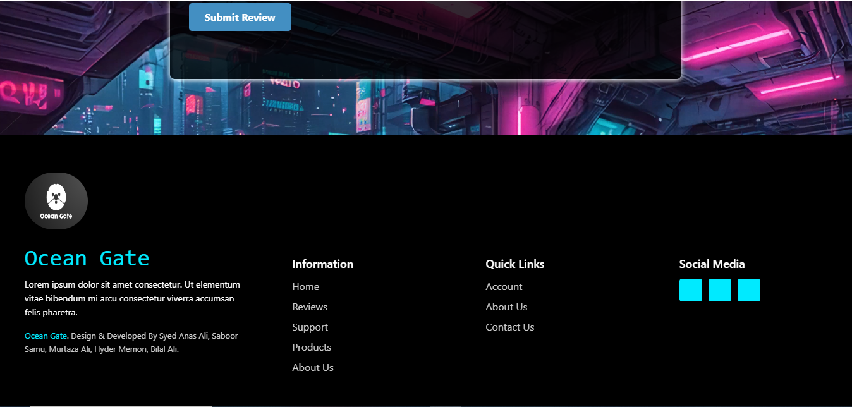

**About Us Page :**

